OffChartCPD
Daily Expedition Safety Briefing
Complete every morning before departing. For winter / mountain expeditions.

Expedition |  | Day number
Date |  | Departure time
Lead guide / facilitator |  | Activity today
Group size |  | Planned return time

1 | Weather

Conditions over the past: 12 hrs · 24 hrs · 48 hrs (circle one) — Circle the appropriate answer in each row below.

Sky / cloud cover | CLR Clear · FEW · SCT Scattered · BRK Broken · OVC Overcast
Precipitation | Nil · Snow · Rain · Sleet | Intensity: Light (1mm/hr) · Moderate (2mm/hr) · Heavy (3mm+/hr)
New snow (past 24 hr) | Nil · <5 cm · 5–20 cm · 20–40 cm · >40 cm
Wind speed | Calm · Light (7–20 km/h) · Moderate (20–40 km/h) · Strong (40–60 km/h) · Gale (60–80 km/h) · Storm (>80 km/h)
Wind direction | N · NE · E · SE · S · SW · W · NW
Solar radiation | Weak · Moderate · Strong
Air temp / FAFL / freeze | Air temp: _______ °C FAFL: _______ m Night freeze: Y · N
Other observations
Forecast summary
Signs of change to watch for

2 | Avalanche Hazard

Mark each segment with the danger rating (1–5) for that aspect and elevation band. Shade or write number in each cell.

TODAY | NEXT DAY FORECAST
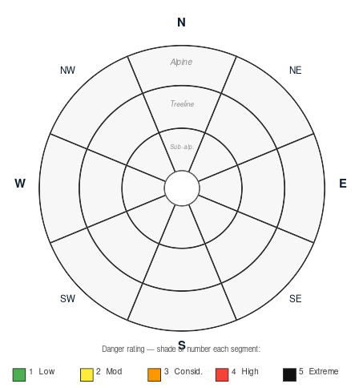

Overall hazard level | 1 Low · 2 Moderate · 3 Considerable · 4 High · 5 Extreme (circle)
Avalanche problem 1 (type, aspect, elevation)
Avalanche problem 2
Aspects & terrain to avoid
Other hazards (rockfall, crevasse, thin pack)

3 | Terrain & Objectives

Primary objective / route
Alternative if conditions change
Turn-around time (non-negotiable)
Key decision points
Escape routes

4 | Group Status

Physical concerns (fatigue, illness, injury)
Psychological / behavioural concerns
Any participant medicated today?

5 | Equipment & Communications Check

☐ Avy transceivers (tested) | ☐ Probes & shovels | ☐ First aid kit | ☐ Helmets
☐ InReach (charged) | ☐ Radios (comms check) | ☐ PLB / EPIRB | ☐ Emergency contacts distributed
☐ Food & water (group) | ☐ Navigation (map / GPS) | ☐ Emergency shelter | ☐ Repair kit

Agreed InReach check-in time
Home base briefed? | ☐ Yes ☐ No — do this before departing

6 | Go / No-Go Decision

Decision | Made by | If NO-GO — reason and revised plan
☐ GO
☐ NO-GO

Facilitator signature

